# Linear Algebra

## Vectors

A vector has a length (magnitude) and a direction. We can see this as a line in a N-dimensional space.

**Example**

2 steps in the x-direction and 1 step in the y-direction

### Vector Addition

Add them head to tail

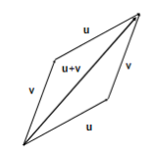

Properties of Vector Addition

* Commutativity: u + v = v + u
* Associativity: (u + v) + w = u + (v + w)
* Identity element: u + 0 = u
* Additive inverse: u + (-u) = 0

### Vector Scalar Multiplication

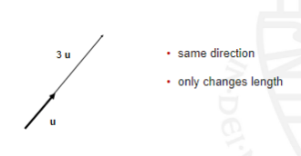

Multiplying a Vector by a Scalar

* Associativity: a (b u) = (a b) u
* Distributivity (I): (a + b) u = a u + b u
* Distributivity (II): a (u + v) = a u + a v
* Scalar identity: 1 u = u

### Vector Space

* Set of vectors with associated set of scalars (real numbers)
* Closed under addition and scalar multiplication
* Any vector can be represented as a linear combination of a basis {u1,..., un}, i.e., we can always find {a1,...,a n} such that

$v=\sum_{i=1}^{n}{}a_{i}u_{i}$

### Basis Vectors

* Basis vectors “span” the vector space
* Dimension of vector space: minimum number of basis vectors needed
* Typically unit length and orthogonal (more later)
* For example, in two-dimensional Euclidean space:

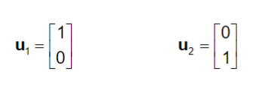

### Dot Product

Dot product also known as scalar product or inner product:

$u⋅v=u_{1}v_{1}+u_{2}v_{2}+ ... +u_{n}v_{n}=\sum_{i=1}^{n}{}u_{i}v_{i}$

### Orthogonal Vectors

Two vectors u and v are said to be orthogonal if $u⋅v=0$. Also could be viewed as a perpendicular

**Example**

$\left[1 2 -1\right]⋅\left[3 -2 -1\right]=1×3+2×(-2)+(-1)×(-1)=3-4+1=0$

### Length and Angles

Length of a vector: $\left|\left|u\right|\right|=\sqrt{u⋅u}=\sqrt{u_{1}^{2}+u_{2}^{2}+ ... +u_{n}^{2}}=\sqrt{\sum_{i=1}^{n}{}u_{i}^{2}}$

Dot product in terms of angles: $u⋅v=\left|\left|u\right|\right|⋅\left|\left|v\right|\right|cos(θ)$

### Projection

Projection of v on u: $v_{u}=\frac{(u⋅v)u}{{\left|\left|u\right|\right|}^{2}}=\left|\left|v\right|\right|cos(θ)\frac{u}{\left|\left|u\right|\right|}$

## Matrices

A matrix is a set of elements, organized into rows and columns usually described as a “n by m matrix” (n rows by m collumns).

### Matrix as a Set of Vectors

The first subscript indexes rows and the second subscript indexes columns.

### 

### Properties of a Matrix Addition

* Commutative: A + B = B + A
* Associative: A + (B + C) = (A + B) + C
* Identity: A + 0 = A
* Additive inverse: A + (-A) = 0

### Multiplying a Matrix by a Scalar

* Associativity: b (c A) = (b c) A
* Distributivity (I): (b + c) A = b A + c A
* Distributivity (II): c (A + B) = c A + c B
* Scalar identity: 1A = A

### Matrix Multiplication

**Example**

### 

### Multiplying a Matrix by a Matrix

* Associativity: A (B C) = (A B) C
* Distributivity: (B + C) A = B A + C A
* Identity matrix: I A = A = A I
* No commutativity: A B ≠ B A